CSE3300/5299, Fall 2025 M. Wang

Sample Final Exam
Name_________________________ Student ID#__________________________

-This is a close-book exam.

-There are 10 exam problems. Please try to complete it all.

-The number of points allocated to each problem is shown.

-Use your time wisely.

-For analytical problems, show all your steps.

-Be specific in your answers. Do not give several answers hoping that one of them is the right answer; if you give n alternative answers to a question, you will get at most 1/n of the credit for the question.

-You have 2 hours in total.

1. True or False. No need to justify.
1.1 After receiving a route announcement, a BGP router must forward the announcement to a neighboring BGP router.

1.2 A TCP sender maintains a sequence number, which is counted in bytes (instead of packets). The sequence number of the first packet in a TCP connection (i.e., SYN packet) has sequence number 0.

1.3 Suppose that during TCP slow start, the initial congestion window size is 1 MSS. Suppose there is no packet loss. Then after 7 round trip times, the congestion window size is necessarily 2^7=128 MSS because of the exponential growth in TCP’s slow start phase.

1.4 The switch table of a layer-2 switch should be configured.

1.5 Hosts A and B are communicating over a TCP connection. Suppose Host A sends two segments back-to-back to Host B, with 1000 and 500 bytes of data in the first and second segments, respectively. In the first segment, the sequence number is 5001. Then the sequence number of the 2nd segment is 6001.

2. Circle the correct answer (only one is correct). No need to justify.

2.1 Which of the following is NOT true?
A. OSPF is a widely used intra-domain routing protocol.
B. Both ARP request and reply are through broadcast.
C. The design of NAT box violates the end-to-end principles of the Internet.
D. None of the above.

2.2 Which of the following statement is NOT True?
A. A router’s data plane forwards a packet from one interface to another interface.
B. A router’s control plane determines the route.
C. A router’s data plane needs to be fast and is often implemented in hardware.
D. A router’s control plane is often implemented in software and has to reside in the router.
E. None of the above.

3. Why does BitTorrent introduce a tracker in the system?

4. Describe the count to infinity problem in distance vector algorithm?

5. Suppose two nodes have the same minimum tentative distance during Dijkstra’s execution. (2 pts)
(a) Does the order in which you select among tied nodes affect the final distances computed? Why or why not?
(b) Could it affect the actual path (the sequence of hops) taken for some destinations? Why?

6. Give an IP address 69.168.192.162/26. (3 pts)
a) What is the network address? Show your work. (0.5 pts)
b) How many hosts are supported in this network. (0.5 pts)
c) Allowable IP addresses for hosts in this network. (2 pts)

7. Why is hierarchical routing introduced? List two common intra-AS routing protocols and one inter-AS routing protocol.

8. In the following example
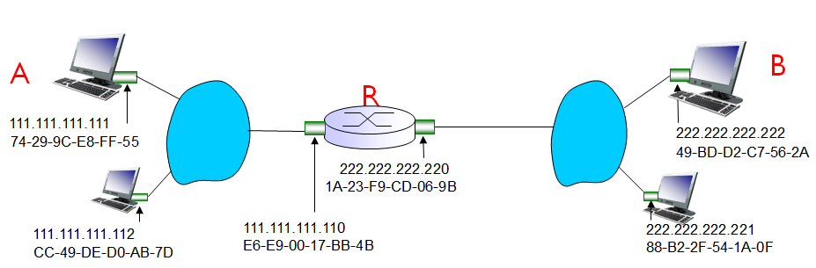
If A wants to send a packet to B.
i. Which destination IP address should A put in the IP header? Which destination MAC address should A put in the Ethernet header?

ii. Will the destination IP address in the IP header change during the transmission from A to B? Will the destination MAC address in the Ethernet header change? If not, explain why. If yes, where does the address change?

9. List the priority of criteria when router needs to select a path from multiple candidate paths (from highest order to the lowest order)
a. additional criteria
b. local preference value attribute: policy decision
c. closet NEXT-HOP router: hot potato routing
d. shortest AS-PATH.

10. Describe the CSMA/CD protocol and its application scenarios, wireless LANs or wired LANs or both, and why?

